<h1> Gold Coast Towing: The Do’s & Don’ts

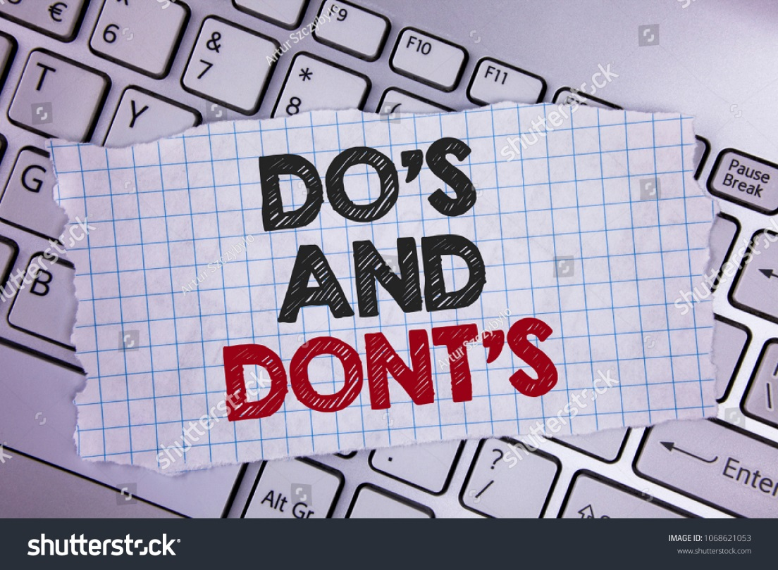

When you are driving or imagine yourself with your very first car, you have never faced a breakdown on the road before, and one day the unthinkable happens, car jolts and stops!
Let’s get some advice on what you should do, and what not to do when faced with such situations.
- When your car breaks down, we usually get tensed and try get out of the car to have a look under the hood. Be careful to first try move your car to the side of the road (away from traffic). Now you don’t want to be in the hospital like your car now, do you? Exactly, self-safety first!
- Remember to turn your hazard lights on. This is the best way to stay safe and make people in the surrounding know that you are facing difficulties with your car and that you are awaiting roadside assistance or towing. Don’t be in a dark spot and expect the towing people to find you easily without your hazards flashing.
- Patience is a virtue, make sure you don’t try and fix the problem yourself, and rather call your towing service company and let them provide you with professional help. Remember, on the Gold Coast, Cheap AZ Towing provides towing assistance as well as roadside assistance, so be sure to contact them when you are in need. If you are even interstate, Cheap AZ Towing will be besides you, whenever and wherever.
- If you are stranded without a phone or reception, be sure to use the emergency phone boxes on the side of the road. Use caution while you walk to the phone, don’t rush! When speaking to your towing company, give them accurate information which would enable them to pin point your location, this would make the search more effective. Don’t call them with less information and expect them to find you efficiently.
No matter where you are, and whenever, if you need assistance with towing or roadside assistance on the Gold Coast or even interstate, remember to call Cheap AZ Towing on 0488 166 449. These professionals are available 24-hours for your need.
Meta: For prompt and professional 24-hour towing on the Gold Coast Call us on 0488 166 449. We can transport virtually any vehicle with our 7 metre 4-ton tray.

