<h1> How is a vegetarian burger as awesome as a meat burger?
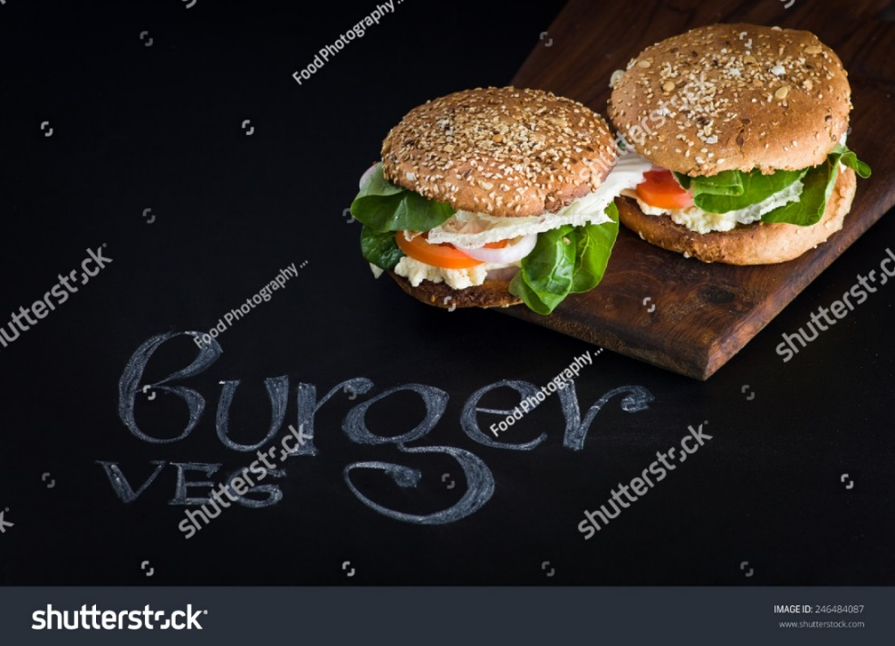
There was a time when vegetarian burgers were considered for weight cautious individuals only, however, now this selection of meal is very popular amongst us as we are more health conscious, so why not try a vegetarian burger nowadays when the taste is as delicious as a meat burger! If you have got an urge to try a delicious burger, be sure to visit Pollo Dory on the Gold Coast for your satisfaction. Let’s check out how vegetarian burgers tackle the competition with meat burgers;
<h2> Calories
In case you're endeavouring to lose some weight, yet you would prefer not to drastically change your eating routine, a veggie burger makes a perfect expansion to your everyday menu. Veggie burger patties are low in immersed fat, making them an awesome eating routine food. A general lean hamburger patty contains around 10 grams of fat, while the normal veggie burger patty just has around three grams of fat. In any case, not all veggie burgers have low fat substance, so ensure that you read the marks. Numerous veggie burgers likewise contain less calories than hamburger burgers. Some veggie burgers contain as few as 70 calories, contrasted with the normal meat burger which can surpass 200 calories for every serving.

<h2> Prevent sickness
Some veggie burgers can profit your wellbeing by helping you avert illness. For example, soy is known to contain phytochemicals that assist to bring down your body's cholesterol, otherwise called the "awful" cholesterol. This cholesterol can block our blood vessels, causing coronary illness or a heart attack. The soy in veggie burgers can likewise enable you to dodge osteoporosis and other bone illnesses, by helping your bones hold calcium.
<h2> Fresh Ingredients
Most restaurants make burgers with patties which come frozen, but a vegetarian burgers most often comes with fresh vegetables. This is because vegetables deteriorate in flavour faster than meat. Well meat can be frozen and used later, but with vegetables it’s not the same case. So on the Gold Coast, no matter if you are looking for a good meat burger or a mouth-watering vegetarian burger, look no further than your awesome takeaway shop, Pollo Dorry!
Thinking of eating out? Thinking healthy? Fish and chips? Want fresh take away food fast? Get it at our burger & fish and chip shop. Call 07 5534 4999 for the tastiest & freshest take away food on the Gold Coast.
Meta: Want fresh take away food fast? Get it at our burger & fish and chip shop. Call 07 5534 4999 for the tastiest & freshest take away food on the Gold Coast.

