Audience: Deaf
Distribution: VICTORIA VRS target list/select Partner target list
Experience enhanced accessibility at National Gallery of Victoria’s Monet’s Garden
View this message in Auslan with captions
Experience Monet’s Garden, in Australia from The Musée Marmottan Monet Paris, via OpenMi Tours this winter.
Showing at The National Gallery of Victoria (NGV) from 10 May – 8 September, this Melbourne Winter Masterpieces exhibition is available for the 17 works in the exhibition.
View content for this exhibition in Auslan with captions on your Android or Apple smartphone or tablet, or borrow one of NGV’s 70 handheld devices.
Audio description is now available for vision-impaired visitors to this exhibition, with each display triggered by proximity detection. Ask about this option at the front desk.
The app is free from the Google Play store or Apple iTunes. To download content for this exhibition open the app, and:
- Tap the ‘download content’ button
- Tap ‘Monet’s Garden’ under the National Gallery of Victoria menu
- Select your communication preference and tap the ‘download’ button under Manage Content
We recommend downloading on a Wi-Fi network before you arrive.
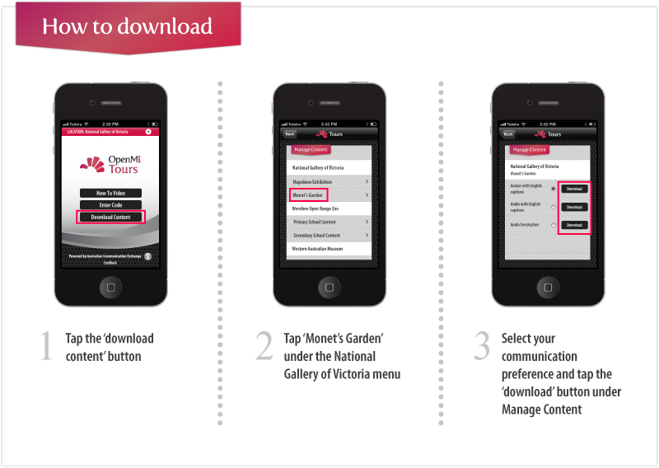click here to enlarge image
Download the OpenMi Tours app and venue content before you arrive:
Android: Visit the Google Playstore | iPhone: Visit the App Store
Please pass this exciting news on to your colleagues and networks.
- More information about Monet’s Garden, visit: The National Gallery of Victoria

- For further information on OpenMi Tours, including further support material visit: OpenMi Tours

We hope you and your family and friends enjoy the tour. Please let us know what you think on our feedback form.
Australian Communication Exchange
295 Logan Road STONES CORNER QLD 4120
PO Box 473 STONES CORNER QLD 4120
Email: info@aceinfo.net.au
Website: www.aceinfo.net.au
Vision: “Access to Communication for Everyone”

Winner of the 2012 National Disability Award for Social Inclusion
Winner of the 2011 Best Captioning Initiative

Stay up to date with our latest news:

You’ve received this email because you are on ACE’s mailing list for OpenMi Tours, if you’d like to unsubscribe, click here.

Audience: Hearing Impaired
Distribution: VICTORIA CapTel target lists/Silent Tweets target list/select Partner target list
Experience enhanced accessibility at National Gallery of Victoria’s Monet’s Garden
View this message in Auslan with captions
Experience Monet’s Garden, in Australia from The Musée Marmottan Monet Paris, via OpenMi Tours this winter.
Showing at The National Gallery of Victoria (NGV) from 10 May – 8 September, this Melbourne Winter Masterpieces exhibition is available for the 17 works in the exhibition.
Receive caption support for the audio tour on your Android or Apple smartphone or tablet, or borrow one of NGV’s 70 handheld devices.
Audio description is now available for vision-impaired visitors to this exhibition, with each display triggered by proximity detection. Ask about this option at the front desk.
The app is free from the Google Play store or Apple iTunes. To download content for this exhibition open the app, and:
- Tap the ‘download content’ button
- Tap ‘Monet’s Garden’ under the National Gallery of Victoria menu
- Select your communication preference and tap the ‘download’ button under Manage Content
We recommend downloading on a Wi-Fi network before you arrive.
click here to enlarge image

Download the OpenMi Tours app and venue content before you arrive:
Android: Visit the Google Playstore | iPhone: Visit the App Store
Please pass this exciting news on to your colleagues and networks.
- More information about Monet’s Garden, visit: The National Gallery of Victoria

- For further information on OpenMi Tours, including additional support material visit: OpenMi Tours

We hope you and your family and friends enjoy the tour. Please let us know what you think on our feedback form.
Australian Communication Exchange
295 Logan Road STONES CORNER QLD 4120
PO Box 473 STONES CORNER QLD 4120
Email: info@aceinfo.net.au
Website: www.aceinfo.net.au
Vision: “Access to Communication for Everyone”

Winner of the 2012 National Disability Award for Social Inclusion
Winner of the 2011 Best Captioning Initiative

Stay up to date with our latest news:

You’ve received this email because you are on ACE’s mailing list for OpenMi Tours, if you’d like to unsubscribe, click here.

Social Media posts:
- Access the upcoming Monet’s Garden tour with the OpenMi Tours free smartphone app for Deaf and hearing-impaired visitors. Download it now on iPhone or Android.
https://itunes.apple.com/au/app/smart-auslan/id528518358?mt=8
https://play.google.com/store/apps/details?id=au.net.ace.smartauslan&hl=en
For further support visit www.openmi.com.au/tours

- Experience Monet’s Garden at the NGV from 10 May– audio tour now available with captions and Auslan via the OpenMi Tours free app. Visit www.openmi.com.au/tours for more information

- Visiting NGV but can’t hear the audio tour? Download the OpenMi Tours free app to access Monet’s Garden in Auslan with captions from iTunes or Google Playstore.
To ensure a seamless experience with the OpenMi Tours app, refer to this checklist:
http://www.youtube.com/watch?v=MYlcbgQphlI&feature=youtu.be

- Experience the audio described tour of Monet’s Garden at NGV. Download the “OpenMi Tours” app for free from iTunes onto your iPhone 4 or 5, or borrow one of five devices from us. Tours will auto-play as you approach each exhibit!

