Summary Report
Communication Technology National User Needs Analysis
A study of the Deaf, Hard of Hearing and Speech Impaired communities’ technology use and communication challenges.
prepared for Australian Communication Exchange (ACE) (date?)

Clarity is the key to effective communication,
so anything to enhance current technologies’ clarity would be great.
Survey Respondent

PART ONE - introductory
This analysis was conducted by Fieldworx for Australian Communication Exchange (ACE) to help identify communciation barriers faced by deaf, hard of hearing and speech impaired Australians, and guide ACE’s work into addressing these barriers.
In 2014 under an organisational restructure ACE donated its research activity to Conexu Foundation Limited, who continue to identify the communciation needs of its community and strive to deliver solutions under its Vision for “A connected and inclusive community”.

Introduction
Conexu Foundation has a strong focus on facilitating research to understand unmet communition and information needs of communication impaired, Deaf and hard of hearing communities, and to help bridge any gaps in communciations technology for these communities.
This report discusses current communication challenges and priorities identified by people who are deaf, hard of hearing or speech impaired, and aims to better understand future needs. It draws on current literature and primary research to offer five recommendations for Conexu’s future development in this area.
The research is designed to inform the contributions of Conexu to the national debate about future services and technologies that will best address the needs of the community as well as provide direction on the future allocation of resources
Definitions and Terminology
For the purposes of this report, we adopt the terminology used by the World Federation of the Deaf and International Federation of Hard of Hearing:
- People with hearing loss (whether mild, severe or profound) may identify as “Deaf” or “hard of hearing”
- The term “hearing impaired” is not appropriate.

Based on feedback from the focus groups conducted as part of this project, we used these categories and definitions in the survey:
- Deaf – a person who uses Auslan to communicate and identifies as a member of the signing Deaf Community
- Hard of hearing – a person who has a hearing loss (of any severity) and whose communication is usually by speech
- Acquired hearing loss – a person with diminished hearing as a result of work, aging or other environmental factors
- Speech impaired – a person for whom speech is either not possible or is difficult and constitutes a communication difficulty.

What would you like to see? “More awareness in the public; to improve communication between a hearing individual and a deaf/hearing impaired individual.” – Survey Respondent

Methodology
The research was directed by the STEERstrategy™ methodology:

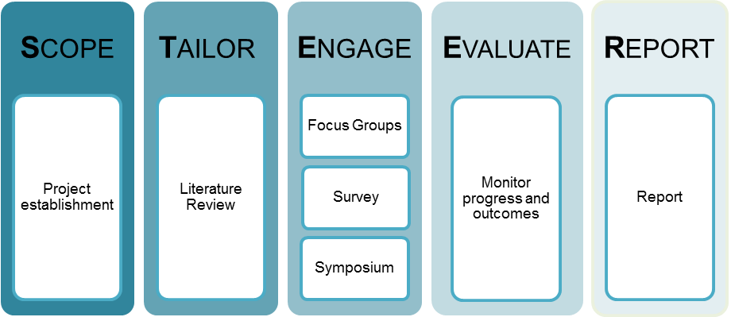

Scope: Agreed and refined during project planning phase to deliver meaninful insights for Conexu.

Tailor: Examine existing literature to tailor primary research. A preliminary literature review was conducted by Social Money Solutions

Engage: A three-stage research approach was employed to engage with communities and stakeholders for this project: focus groups, a national survey, and a symposium.

Evaluate: Fieldworx managed the research process to ensure client satisfaction at every stage of the project. Social Money Solutions were responsible for direct project management.

Report: Outcomes of the literature review, survey, focus groups and symposium are combined in this report and presented alongside Fieldworx’s recommendations.

Key Recommendations
That ACE works with peak bodies to advocate for more in-depth surveying of the deaf, hard of hearing and speech impaired communities in Australia, beyond that of the ABS. Consideration is needed about how to include those individuals who suffer a loss of hearing, but do not identify as having a disability in the traditional meaning of the word.
That ACE provides or advocates for a central information source or website that promotes communication technology products and services to individuals and employers.
That future product and service development by ACE addresses the need for fast, natural and immediate communication through existing mainstream, non-proprietary equipment.
That ACE conducts further investigation into the commercial viability of the solutions suggested at the symposium. Within this context, that ACE considers prioritising solutions for a single information source, cinema captioning and data plans.
That ACE conducts specific market testing into the commercial viability of establishing a community telco.

PART TWO- Investigation (unpacking the methodology)

Preliminary Research

Literature Review: Deafness and Speech Impairment in Australia
Conducted by Social Money Solutions

Summary of Findings & Outcomes

Size of deaf and hard of hearing community: Though there is extensive information available about the size and definitions of the deaf community and those with hearing loss there is considerable inconsistency within this information. Definitions are largely determined by the individuals themselves. A combined population can be surmised from a range of sources, a summary of which appears in the table below.

Comparison of the deaf, hard of hearing and speech impaired population in Australia, including future projections
 | 2004 | 2009 | 2010 | 2011 | 2012 | 2020
Johnston | 7000 | - | - | - | - | -
ACE |  |  | 3,000,000
ABS (SDAC) | - | 310,175 | - | - | 1,175,000
Access Economics | - | - | 4,017,664 | - | - | 5,087,109

The Australian Bureau of Statistics: The Australian Bureau of Statistics (ABS) released their findings from the 2012 Survey of Disability, Ageing and Carers (SDAC) in November 2013. Fieldworx reviewed the SDAC categories to achieve comparability by identifying those SDAC categories that could be grouped together to provide comparison to the widely accepted terminology of deaf, hard of hearing and acquired hearing loss.

Percentage of SDAC respondents by identified hearing loss

Communication amongst deaf and hard of hearing: There is little recent research examining the use of communication technology by those identifying as deaf or hard of hearing. Much of the available research comes from the United States which may not be relevant in the Australian context. From preliminary research it was evident that many deaf and hard of hearing people are limited to participate in social activity in a free and natural manner. Technology has been identified as means of achieving equity in social participation.
Future Projections in the Literature: Australia’s deaf population is predicted to grow to approximately 8 million by 2050 (around 26.7% of the population), with the majority aged over 71 years (Listen Hear!; The Economic Impact and Cost of Hearing Loss in Australia, 2006, p. 42). This projection is based on the aging of the Australian population, and does not take into account any environment, technology or policy changes.
The ABS data is based on perceived disability and impact to core functionality. Making comparisons and undertaking trending analysis between successive SDAC data sets difficult, due in part to later surveys attempting to obtain better coverage of disability and of tasks and activities that were previously considered too sensitive for a population survey. The expansion of the disease of the ear and mastoid category in the 2012 survey is an example of this.
There is general consensus that the 2012 SDAC data is under-representative of the community.
The 2006 Listen Hear! Report used extensive statistical analysis to estimate the size of Australia’s deaf community and calculate the existing and future economic impact of hearing loss. That report confirms the difficulties involved in attempting to quantify the deaf and hearing impaired population.
The lack of reliable data about the population affected by hearing loss makes it difficult to plan products and services for the community. This is compounded by lack of evidence about the number of people who experience speech impairment. Reliable current data and strong future projects would assist service providers like Conexu to plan for the future needs of the deaf, hard of hearing and speech impaired community.
Recommendation – That Conexu Foundation works with peak bodies to advocate for more in-depth surveying of the deaf, hard of hearing and speech impaired communities in Australia, beyond that of the ABS. Consideration is needed about how to include those individuals who suffer a loss of hearing, but do not identify as having a disability in the traditional meaning of the word.

Community Engagement
Focus Groups
Fieldworx undertook three focus groups with identified stakeholders and community members to gain insight into the issues faced by the community in relation to communication technologies.
The first two focus groups, were used to inform and refine the survey. These groups undertook a process to identify key issues from their personal and anecdotal experiences. The third focus group was a symposium at which the outcomes of the survey were delivered and the participants’ responses gathered to inform this report. The symposium also examined communication challenges of the community and proposed solutions to the issues identified.
Survey
A survey was developed from the focus group outcomes and consultation with ACE’s managers to gather data on:
• People’s use of technology in their daily lives
• Satisfaction levels with the technology they use
• The reasons people may not use technology
• Reactions to the concept of a community-based telecommunications service provider for the deaf and hard of hearing community (with a goal to provide an initial snapshot of the market’s view about this concept).
To ensure accessibility, Auslan translation was included in the on-line survey for each question. Respondents were also invited to respond via Video Relay Service interpreters or to complete the survey in hard copy.
The survey was distributed to individuals on ACE’s email database and the databases of associated organisations that serve the target community. This process was used to enable a sample of responses across age and hearing status categories.
Demographics: The survey was completed by 375 individuals - 36% identified as male, 64% identified as female. The segmentation of survey respondents according to their identified hearing loss used the same categories as the ABS study. However, our study allowed respondents to self-select their segment, while the ABS survey was driven by a medical definition. Interestingly, the segmentation in our study is quite different from that identified by ABS. In our study, the majority of respondents (47%) identified as “hard of hearing”, rather than falling into a medical definition of “deaf”; in contrast, the ABS data identified 7% of respondents as “hard of hearing”. Only 30% of respondents to our study identified as “deaf”, compared with 82% of respondents in the ABS data.

The group of speech impaired people represented in our survey is very small. Unfortunately this makes is impossible to draw any conclusions about the communication technology needs of speech impaired Australians.
The demographic data from our survey population is shown in the following charts.
Respondent population by identified hearing loss
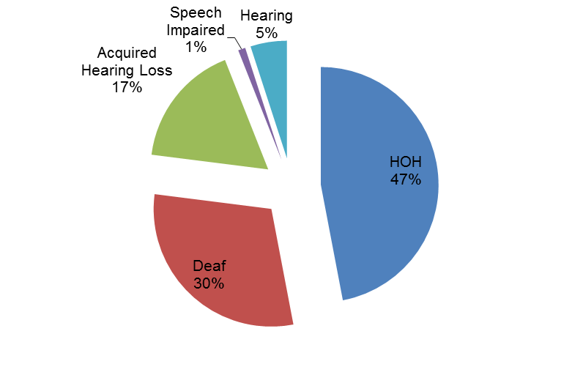
Employment status: Respondents in our survey identified in the following employment categories:
• 46% in full or part time paid employment
• 10% undertaking formal study
• 3% unemployed and actively seeking paid employment
• 11% volunteering
• 30% retired – no longer engaged in any paid employment.
- 14% both working & studying

Communication technology use:
46% indicated that they did not use technology.
Reasons for not using technology included:
- Lack of interest
- Lack of awareness
- No available technology for the individual’s specific communication needs
“They do not help me communicate”
“I don’t know how to use them”
“I do not know anything about them”
Usage by age demographics yielded surprising results:
- 53% of the under-35 age group indicated that they did not use technology to communicate
- 41.5% of the 36-65 group indicated they did not use technology
- 32% of the over-65 group indicated they did not use technology
54% of survey respondents indicated that they used technology to assist in their communication.
“It helps me communicate”
“It can be used in all aspects of life (work learning or socially)”
“It is immediate and natural, and easy to use”
Recommendation – That future product and service development by ACE addresses the need for fast, natural and immediate communication through existing mainstream, non-proprietary equipment.
The survey was distributed electronically, so respondents must have had access to communication technology to be able to respond. It is possible that respondents do not view mainstream technologies (such as smart phones, tablets, and so on) as specific communication technologies for people who are deaf and hard of hearing. The cost of some technologies may also be prohibitive to this group gaining regular access to certain technologies.
Recommendation – That ACE provides or advocates for a central information source or website that promotes communication technology products and services to individuals and employers.

Open Mi Access:
50% of survey respondents were aware of the Open Mi Access applications. It is possible that these results reflect limited availability of the application at venues. Another possibility, which was mentioned in the focus groups, is that venues themselves often don’t know about the application or volunteers don’t know how to work the application – these problems cause user frustration and abandonment of the technology.
Technology use at work, at school and socially:
Of the 46% respondents in employment, most felt adequately supported at work with communication technology, but 31% reported a social divide at work, indicating they did not participate in work social functions because of communication challenges. A similar response was received by respondents in the education system – they felt their hearing had an impact on social participation.
The major challenge reported by working respondents was the compatibility of specialist technology with their employer’s IT and telephony platforms. A common example was the need for CapTel handsets to use copper wire, while a lot of employers and large organisations were moving to VOIP technology or solutions that do not use copper wire. This could mean that the installation and setup of equipment for respondents was a difficult (bureaucratic) process and, in some cases, a significant employer expense.
Information access:
Respondents reported their sources of information on communication technologies included:
- Internet search engines
- Word of Mouth
- Information provision emails from ACE and other organisations

Where do you go to find out about available communication technologies?
“I don't get any information on communication assistance.”; “I don’t know where to look - I use what I have and watch shows with subtitles”; “Don't go anywhere! I didn't know half these places existed” – Survey Respondents

The greatest challenges:
The three greatest challenges identified by respondents were:
- Attending social events (204 respondents)
- Going to the movies or theatre (193 respondents)
- Dealing with financial institutions and government departments (147 respondents).

What is the greatest challenge you would like overcome to make your life more enjoyable?
“More awareness in the public, to improve communication between a hearing individual and a deaf/ hearing impaired individual.” - Survey Respondent
Respondents’ frustrations can be broadly categorised into three groups:
The need to generate greater awareness in the community of the communication challenges faced by the deaf and hard-of-hearing community
• The need for greater accessibility to existing services (both ensuring that people are trained in the use of existing or available technology and that technologies are financially accessible)
• The need for greater use of existing mainstream technologies amongst the non-hearing and speech impaired communities.
Symposium
A symposium was held following the completion of the survey to verify and explore the survey findings. The main purpose of the symposium was to facilitate idea generation and inform recommendations to ACE on potential areas for further investigation, research or investment over the next 5 years.
Symposium Outcomes:
A symposium was facilitated by Fieldworx, and made up of 20 participants identified by ACE from the deaf, hard of hearing and speech impaired community. The Agenda for the symposium was to review the results of the survey, and using those results undertake a process with the attendees to generate and capture potential solutions for communication challenges. These solutions can be investigated by Conexu and inform Conexu’s priorities over the coming years.
The symposium process followed four steps:
1. Identifying the broad principles for technology development
2. Generating blue-sky ideas, where every idea was captured, no matter how far-fetched or unrealistic
3. Refining the blue-sky ideas into six concise ideas
4. Exploring the six ideas by asking two questions: “what is the problem we are trying to solve” to determine the root cause, and “what do we want it to do” to define operational requirements.
Guiding principles for developing technology for the deaf community:
The symposium participants developed these guiding principles for development of future technology or software for the deaf community:
• Any technology should be discreet, easy to use and mobile
• Development should be done on mainstream platforms and technologies and align with the NDIS framework
• Technology needs to be relevant, quick to use and learn, and reliable
• Education and demonstration of the benefits and use need to form part of the delivery.

PART THREE – (explaining the recommendations)
Evaluations & Recommendations
Priority problems and their solutions:
Priority | Problem | Solution
Product and services portal | A lot of services/information, hard to know where to look. Google main resource but too broad/biased. | A website resource to bring up to date unbiased information together for easy user-friendly access. Its usefulness to be monitored.
Integrating communication options in contacts | Users cannot directly link to existing NRS services from central location | integrated contacts database, either standalone or proprietary to a phone hardware provider, that allows users to input details for NRS, VRS, Skype and so on
Captioning for cinema | Captiview system that currently exists in Australia does not meet the demands of the deaf community | trial of new technologies in conjunction with an independent cinema chain. Technologies that provide on-screen captioning (such as invisible captions and Sony Caption Glasses), which are currently available outside Australia, are less intrusive and allow people to have greater control over their movie-going experience.
Interpreter services portal | No immediate and centralised access to interpreter services | online portal, based on the technology used in websites such Webjet, that allows users to choose from a selection of providers and gives options about searching (on availability, provider, price, and so on
Backup emergency alert system | Communication, particularly in emergency situations, is heavily reliant on mobile phone technology. If a mobile phone has lost battery power or is damaged by water, deaf and speech impaired people may be left without help or support. | small, indestructible, 4-button LED device that works on satellite technology and allows people to call emergency services (fire, police, ambulance or SES) and communicate via text messaging.
Affordability of mobile data | cost of mobile data in Australia is still high. Many person-to-person communication application require data to work. | Advocacy to government agencies and service providers to lower the cost of data – if not for everyone, then for those who use data rather than voice as their primary means of communication. Participants also suggested that a community-focussed telecommunications provider could seize this opportunity in the market.

The commercial viability of the solutions to the six issues identified at the symposium should be investigated. the solutions that bring consolidation to service providers and could be self-funding or income generating appear to be most viable. These are also the solutions that are likely to address the concerns raised in the focus groups and survey about the lack of available information about services.
Recommendation – That ACE conducts further investigation into the commercial viability of the solutions suggested at the symposium. Within this context, that ACE considers prioritising solutions for a single information source, cinema captioning and data plans.

Community Telecommunications Provider:
Survey respondents gave overwhelming support to the establishment of a community telecommunications provider, with almost 90% indicating they were either interested or definitely interested.

Percentage of respondents likely to switch to a Community Telco
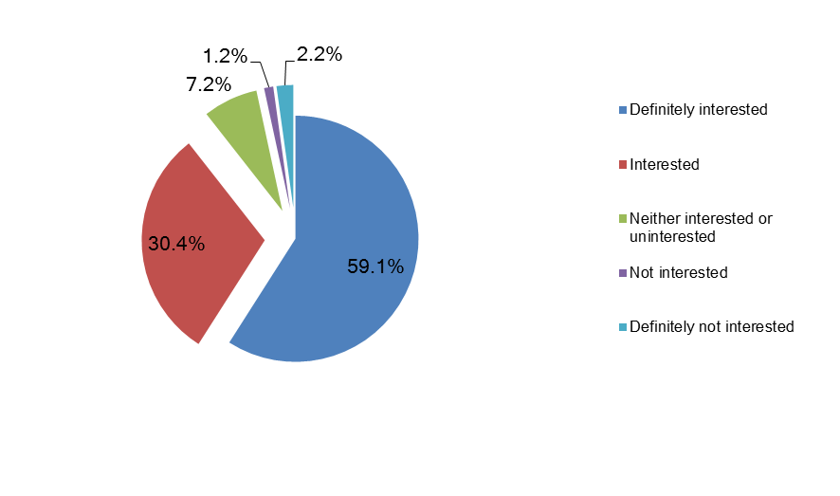
Highest interest areas for respondents interested in CTP
Example services | Interest from Respondents
Data and text only mobile plans | 42%
Subsidised equipment purchase plans | 42%
Discounts for bundled services | 48%

Recommendation – That ACE conducts specific market testing into the commercial viability of establishing a community telco.

Future Opportunities
This research suggests that there are a number of opportunities for ACE that are worthy of further research.
Respondents to the survey and participants in the focus group and symposium overwhelming commented that, while there are plenty of services available, knowledge about them and how to find them is lacking in the community. It appears that there is great opportunity for ACE to take on an education or advocacy role, not only about ACE’s own services (which the survey indicates are little known), but also about services that are available more broadly.
This research reveals that there is a high level of technology use within the community. However, respondents revealed surprisingly little knowledge about what was available, and that they did not know where to find out about what applications could do or be used for.
The key point of inconsistency in this research (which is also evident in the community itself) is the definition of “deaf”, “hard of hearing”, “acquired hearing loss” and “speech impaired”. While this is not unlike many minority communities, there is an opportunity for ACE to adopt and promote language in line with the WFD and IFHOH conventions.
A theme throughout all of this research was the overwhelming message that people want to communicate with each other in ways that are quick, easy, non-intrusive and fluid. While realising this may be some way off for the deaf, hard of hearing and speech impaired communities, there are many opportunities for ACE to promote existing services, applications and technologies. There are also opportunities to explore new and emerging technologies and advocate for their introduction into the Australian marketplace.

“I want the world to be accessible for me”. Whether hearing or non-hearing, this is really what most people want.” – Survey Respondent
Acknowledgments
Thank you to ACE’s partners for assistance in engaging the community for this research. Deaf Australia, Deafness Forum, Hear For You, VicDeaf, Deaf Children Australia, Better Hearing Australia (VIC), Better Hearing Australia, Victorian Deaf Education Institute (VDEI), Deaf Victoria, ACE’s Consumer Advisory Group, Victorian College of the Deaf and CICADA Qld.

Sources of Information
Johnston, T. (2004). W(h)ither the Deaf community? Population, genetics, and the future of Australian Sign Language. American Annals of the Deaf (5), p. 367
Listen Hear!; The Economic Impact and Cost of Hearing Loss in Australia, 2006, p. 42
Access Economics, 2006
Australian Communication Exchange
Australian Bureau of Statistics

