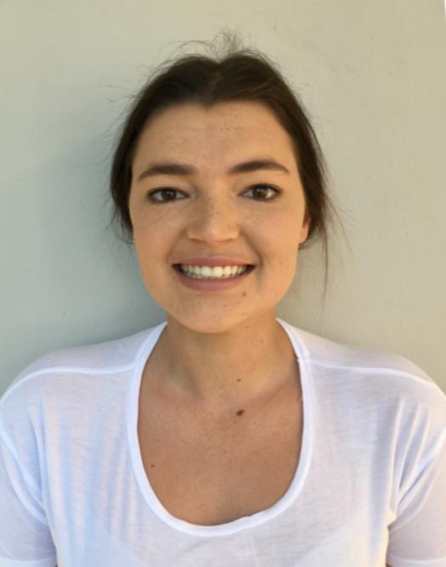
SARAH CURRIE
Stewardess
CONTACT
Email: curriesarah1996@gmail.com
Current contact number: +27 79895 0082
Date of birth: 27th April 1996
Nationality: South African/ New Zealand
Languages: English, Zulu, Afrikaans
Health: Fit, healthy, no piercings or tattoos and a non-smoker
Marital Status: Single

OBJECTIVE
I am a hardworking 6 ft. tall . individual I am looking to become a stewardess, on a motor yacht .I am a positive, hardworking South African and holderof a New Zealand Passport. I am a great team player who always carries a smile on my face.

QUALIFICATIONS & CERTIFICATES
Licence/certificate title
- Elementary first Aid
- Proficiency in designated security duties
- Fire Prevention and Fire fighting
International drivers licence

- Personal safety and social responsibility
- Personal Survival techniques
- ENG1

YACHTING EXPERIENCE. —Temp Stewardess, M/Y Diamond, 29th June-2nd October 2019. Roles rotated between laundry, housekeeping and service during a busy 3 months on board. —3rd Stewardess, M/Y Vega- 06 June 2019- 20th June 2019. Roles rotated between service (silver), housekeeping and laundry. —Permanent contract, M/Y Maria - 65m- 8th October 2018- 17th April 2019. Roles rotate between housekeeping, laundry and occasional service. 10 week Boss trip as the owners are on board for majority of the year. - -Temp Stewardess. M/Y Nirvana 90m- 7th September - 28th September Ship yard period, involved in detailing, dust vac, crew mess organization, all guest area bathroom cleaning, provisioning. Day work, M/Y Aura, 36,6 m Benetti- 8th August Detaining of all cabins, bathrooms, and salons. —Boss trip, M/Y Neoprene, 33,5 m : 3rd – 7th August 2018. Temporary nanny for 9 month old and 3 year old
—One week charter, M/Y Boomerang, 20m – 22nd -30th July
I was a sole stew/cook and deckhand for a seven day charter with seven guests on board
—Day work, M/Y Aura, 36,6 m Benetti- 17th-18th July
Detailing laundry, Detailing cabins, Making beds, Cleaning and detailing of bathrooms and toilets, Detailing Bridge, Detailing Crew mess.

INTERESTS
Outdoor activities
Fishing
Traveling

EXPERIENCE
AU PAIR
McCorquodale family, Grantham, England
February 2018- 19th June 2018
Loftus Family, Stellenbosch, South Africa
February 2016- November 2017

EDUCATION
St Johns DSG Pietermaritzburg 2014
Bachelor of Arts in Development and Environment Stellenbosch University 2015- 2017

SKILLS
I am hard working, punctual and enthusiastic. I have the ability to work effectively and efficiently as part of a team I am highly reliable, organized, adaptable, versatile and have great cooking skills, I have an ability to identify and solve most problems or situations Thus as a result of my bubbly, energetic confident personality.

Concern for the happiness and well-being of others
Cooking
Adventure

REFERENCES
Name | Email | Contact number
Bianca McCorquadale | moorebianca@outlook.com | +44 7884 178045
Gillian Eddles 2nd stew aura | gillyeddles@gmai.com | +27 72 257 7040
Lauren burke | chiefstew@yachtnirvana.com
William (captain, neoprene) | myneoprene@outlook.com
Claire Szekeres (MY Maria) | chiefstew@yachtmaria.com | +34626914684
Graham marsh - captain | captain@yachtmaria.com
David Slee | captain@yachtmaria.com
Jessica Orr | Chiefstew@myprojectmariposa.com | +336147229
Brendan Mustoe/ Mark Spavins | captain@myprojectmariposa.com | +33614727227

