Recruitment and Selection
Nicole Hatcher
Webster University
3 May 2019

- Introduction
Recruitment and Selection are two separate HR functions but with the common goal of finding the right person for the right job. They involve various processes and methods of attracting the right people and select the best person in this pool of applicants. Recruitment is the process of generating a pool of candidates for a particular job, selection on the other hand is the process of selecting which among the pool of candidates is the right person for the right job at the right time.
According to a white paper published by CV Library titled “What does 2018 have in store for recruitment?”, when organizations were asked about their top recruitment priorities in 2018, they cited the following:
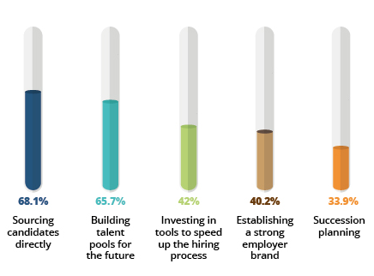
Organizations must divert a significant amount of its resources to this vital HR function as having the right person for the right job is key factor to organizational success. The process in which an applicant becomes an employee differs amongst organizations. Selecting and recruiting employees requires a very detail process from the time an applicant applies for a job down to the interview process. Every step in between proves critical to select the right candidate for the job to ensure you are hiring a deserving, committed, and loyal employee. This paper aims to highlight the importance of recruitment and selection describing in detail the typical process used by organizations to hire employees.
- Recruitment
Recruitment is one of the primary activities of an organization to attract employees and generate a pool of candidates so that the company. The effectiveness of recruitment activities determines the success of employee selection. There are three important elements that must be taken into consideration for recruitment to become successful. These are employment brand, recruitment process and recruitment methods.
- Employment brand
Branding mold the organization in all aspect from culture, values, mission and reputation. The brand image is the simplest definition of an organization which results to efficient recruitment when candidates find it positive. Its been a challenge for every employer to attract and retain their talents and through this, they can efficiently maintain it. Through employee branding, business can convey the identity of the organization, culture environment and the reason why employees must choose them. This helps the company to get the right candidate and help the existing workers to have a sense of loyalty in the organization.
The graphic below quantifies the reasons employees choose to work for an organization. This is taken from the survey of employees in UK.

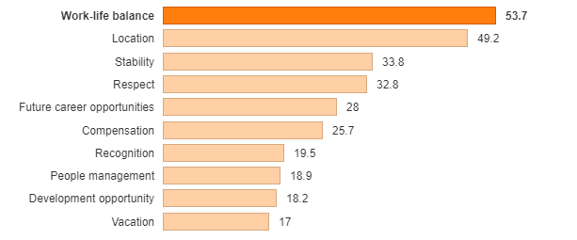
Source: Morton-Hedges, Hannah (2014). What do employees from around the world look for in a job? https://www.theguardian.com/careers/careers-blog/what-employees-want-job-company-around-world

This is who applicants and employees perceived the organization as an employer. A strong employment brand is one that clearly communicates the culture of an organization, including its mission and its values. A strong employment brand gives applicants and candidates a compelling reason why they should work for the company and stay with the organization for a very long time. Virtually all companies have an employment brand, but not all of them realize how critical employment brand can be when it comes to attracting and retaining talents. Several strategies could be used for employer branding and one of these is social media. HR professionals have identified the power of information sharing for employer branding that could be obtained through the rapid growth of social media usage (Bondarouk, & Olivas-Lujan 2013).
Research has indicated that companies with strong employment brand attracts at least 3 times more applicants per job posting than any other company in the same industry (Mitchell, 2007). Employees often cite the company’s reputation as one of the reasons why they apply and decide to work. The company employment brand is a very good strategy in the recruitment process and permeates every aspect of talent management. To be successful in recruitment, a company must invest in long rigorous process to build its employment brand. These rigorous processes include, first, assessing its employment brand through passive and active research that involves employees and outsiders. Second, clearly communicating value proposition by defining it and describing it as simply as possible and finding something meaningful about the organization.
Third is to communicate the brand loudly and clearly both internally and externally. Finally, the company must evaluate its employment brand if it is effective in attracting employees, if find ways.
- Recruitment process
A good recruitment process can minimize the time involved in the searching, interviewing, hiring and training. It can streamline these processes and make your search for viable candidates much more efficient. It is very important to build a positive image to your customers, peers and competitors. (Zahra, 2015). The recruitment process involves three primary elements: planning, job posting and communication.
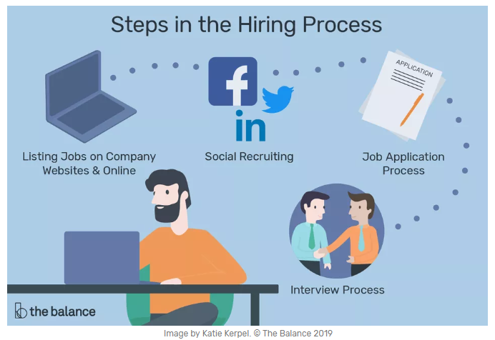
Through planning, the company understands why it is recruiting, identifies its objectives and employs strategies on how to attract the type of employees it needs. When planning, the company, must consider the how much money is available (budget), how quickly must the position be filled (timing) how big is the audience (scope) and the level of the job or what level in the organizational structure does the position fall. Also, for optimal success, recruitment managers must use weekly staff meeting to ask recruiters some important questions such as: What new requisitions are in the new horizons; What assistance do you need; and what obstacle are you facing? (Pritchard, 2007). This allow the recruiters to know that management is committed to facilitating proactive recruiting. After planning, the company apply job posting. Without posting job announcements, the recruitment process will be hindered unless the job announcement is for internal hires.
Job Posting is creating and distributing a notice about a current job opportunity to allow for application of recruitment methods. It is the most frequently used technique to communicate job openings to the target audience. It is built directly from job description. Job positing also applies employment branding in containing information about the job which may include a summary, a central function among others. The goal of job posting is straight forward- to get the word out in as many as applicant as possible about the job position.
Communicationis the information shared between the employer and a candidate throughout the recruitment process itself. Candidate communication is crucial to hiring success. Maintain communication to applicants to send them the message that you value them. In many cases, applicants will have to wait for a very long time to hear from the organization, and so times never hear from it. With great communication, the candidate will most likely consider the company as an employer and will speak more positively of the organization to others. The recruitment process is concern of generating interest in the company. The company may not have a job for the applicant at the moment, but he maybe the right person for a future job. In the recruitment process, always leave the applicant with a good impression of the company. The company will never know when it will be going to need the applicant in the future.
- Recruitment methods
Recruitment methods are the strategies utilized by the company to source candidates. Successful organizations recognize that it is important to use both external and internalrecruitment methods. External means outside the organization and internal means inside the organization (Ash, 2013). Internal and external hires require announcements to be posted in order to select the most qualified applicant for the job. Hiring internally have many benefits, however your pool of applicants is limited. External hires bring the company new and creative ideas and a competitive spirit.
A third party can also be used as part of company’s recruitment method. This include the use of private employment agencies, professional bodies, management consultants, employee referral, voluntary organizations, trade unions, labor contractors and job fairs in order to establish contact with the job seekers. The challenge now is which particular method to be used is right for the company. The answer to it will have to depend on the policy of the company, the position of the labor supply, government regulations and agreement with the labor organizations. The best recruitment method is to look first within the organization itself. Knowing the advantages and disadvantages of these type of methods will give the company the opportunity to make inform decision in the recruitment process.
Below is the diagram that summarizes the pros and cons of recruitment methods:
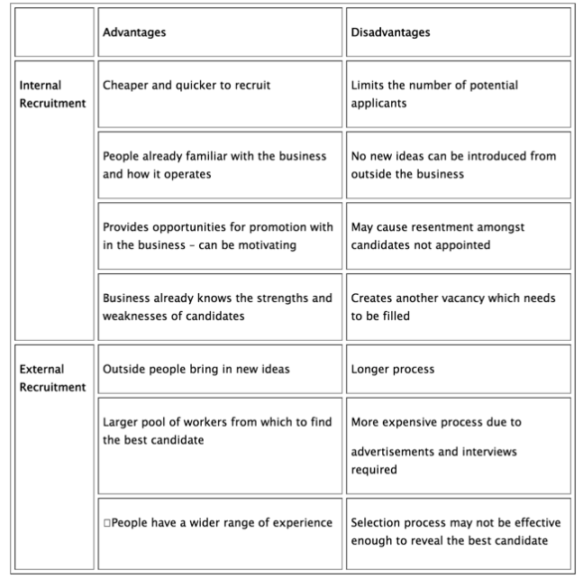
Source: People Management: Methods of Recruitment (GCSE), https://www.tutor2u.net/business/reference/people-management-methods-of-recruitment-gcse

- Determining Recruitment Methods
The use of the methods can reduce resources and time when it comes to selecting potential candidates for employment (Leonard, 2019). The initial step is identifying the need for jobs.

- Needs for jobs.
Recruitment starts when the need for a job is identified. There are several reasons why a need for jobs arises. Employee turnover or attrition is one reason why a company should recruit. When employee leave the company, a job position is vacated and must be filled in. Some of the jobs and duties of the leaving employee may be allocated to others but this is just temporary as it increases the work load of co-workers compromising both their efficiency and motivation. Company growth is another reason why a job need may arise. If the company grows and expands, new departments will be created, the new department create new jobs, hence, there is a need for more people. Appropriate planning, appraisal and assessment of the job need will prompt employing the perfect individual for the job and team. For newly created positions, it is important to comprehend and take into contemplationsthe strategic goals of the company and determine if there are imminent changes that may influence this role. Conduct a core competency analysis and determine if there are core skills missing from the division or department. Furthermore, it is important to evaluate skills that the company currently needs and the skills that may be needed in the future. Then conduct a job analysis to determine if this position will be new to the company. This information will influence decision in selecting recruitment methods.
For replacement due to attrition, replacing the employee with a new one is the logical step to take. Before posting the job, position and advertising it, it is important to conduct job analysis to modify the position according to what is currently needed and to ensure appropriate classification. Usually an HR Classification Analyst takes care of these tasks especially on reviewing and completing.
- Updating and Maintaining job description
Job description contains all the necessary elements that can create job postings and performance goals. The company may experience changes from time to time, hence, it is important to update and maintain job description to address the changes Job description are valuable, they are not only use for recruitment, they can also be used for performance management and compensation. Also, if job description is not kept up to date and an employment case was raised against the company, it can do much damage as a good one could benefit the company. It can work to help defense, or it can work to help the complainant. Job description have legal implication. If the company has a performance measure that does not appear in the job description and an employee file a complaint, the company might have to throw money for damages.
Below is a sample job description of a marketing job in a company.
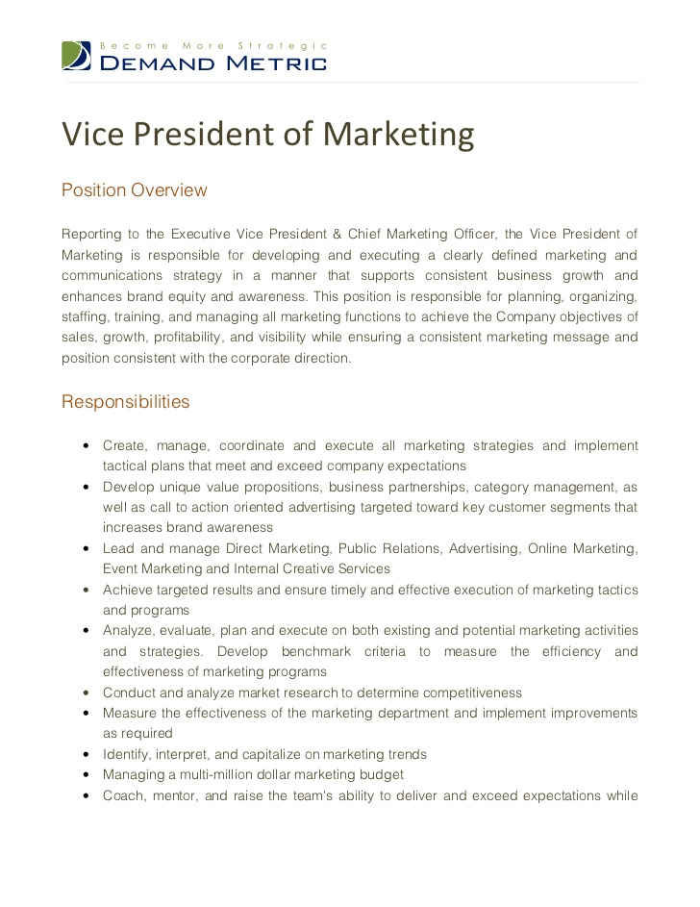

- Internal Recruitment
Internal recruitment is recruitment within the organization. The company employee is the target of recruitment. Strategies used in internal recruitment are job boards and posting systems, recruitment data base, internal advertisement, promotion and transfers. The advantage of internal methods is cost effectiveness and the advantage of familiarity. Advertising the job within the organization is free. The company does not need to spend a single dollar. Familiarity is also an advantage. The employee already knows the organization notable its culture, values and rules. There is no need for employee orientation or on boarding program which are always costly endeavors. Internal recruitment also motivates employees, as create an impression that there is opportunity for career advancement in the organization. The lack of opportunity for career advancement is always cited as the number reason why employee leave the organization (Deery, 2014). Internal recruitment is also efficient as performance data of applicants is available and on the hands of the HR. The disadvantage of internal recruitment is that it creates vacancy. The applicant will leave his job to apply for the newly open position. The logical step will be to fill the vacated position and conduct another recruitment initiative, hence there will be two recruitments instead of one. This incur extra effort on part of the HR. It also fosters unfriendly competition as employees who were not selected may question the fairness of the process. They may resist the decision and may cause problem in the organization. In some cases, they may leave the organization which again force the company to recruit and fill the vacated position.
- External Recruitment
External recruitment is to recruit applicants outside the organization. several strategies are used to recruit external applicants. High on the list is advertising. This is to advertise the vacancy in print ads, newspaper, radios and local TV programs. This is a costly endeavor as the company needs to pay a significant amount of money for the job to be advertise in the said media. At the advent of social media technology, companies shifted their advertisement to popular sites such as Facebook and twitter. Social media advertising is the cheapest way to advertise a job vacancy. The company creates a twitter account, invite followers and tweet the job vacancy. The same methods are usedon Facebook. The company may create a page and post the job vacancy on that page. If it wanted to boost its posting to reach a greater number of applicants, it has to pay a small amount for boosting usually not more than 10 dollars per post. Another form of external recruitment is job fairs. Employers attend a job fair expo often done in college campuses or in townhalls and the company provide a table or booth. Job seekers attend this job fairs and fill out resume and engage in on the spot interview. Temporary employment agencies are also a good source of applicants. The agency provides possible employees to the company.
- Cost of recruitment
Recruitment is a costly endeavor, before embarking in this endeavor, HR manager as well as should determine the cost of recruitment in order to track recruiting budget and plan the entire recruitment method. The recruitment cost is described as the total amount spend to recruit or hire a candidate starting from the job posting to joining the organization. In a simpler sense, this is cost per recruitment or placed candidate. Analyzing the recruitment cost is important for profit analysis of an organization. Most of HR managers or recruiters are not aware of this that is why they cannot determine whether their recruitment process is effective or not.
In order to determine the total profit of a company, it is important to factor in the recruitment costs and the total amount spent while recruiting. This is necessary in evaluating the effectiveness of the hiring process and the individual profit gain of the company as well. The Society of Human ResourceManagement (SHRM) created a formula for calculating new hires. 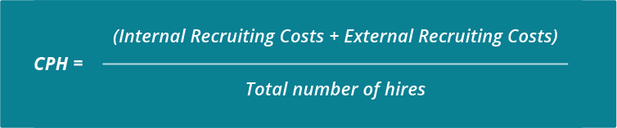
According to the American National Standard for calculating the cost-per-hire, in order to get the average cost per hire, it is necessary to add up all the cost of hire both internal and external and then divide that sum by the number of hires in a certain period. Using this method determines cost used for a specific time period which factors in spending on recruitment such as job fair, advertising, third party agencies coupled with full salary and benefits. The total of these internal and external cost divided by the number of full and part employees equal your cost per hire. (Shapiro & Stanley, 2012).
The cost per hire is the average amount of money spend on making a hire. The metric is useful in tracking the recruiting budget of the company. Like for an example, if the organization wanted to hire 100 people each year, the cost per hire is $4,000 and the total estimate spend of $400,000 for recruitment. Internal recruiting costs are the organizational costs and internal expenses from the salaries of the HR and expenses on referral program. The external recruiting costs are the expenses being paid outside the company from job board fees, agency fees and background check expenses.
In the recent survey by the Society of Human Resource Management (SHRM), the average cost per hire is just over $4000 which is the average cost across all companies that SHRM had surveyed. But there are also other several factors that can affect the company’s individual average cost. For example, the cost per hire depends on hiring volume. The more people that the company hires, the lower the cost per hire. This is because the fixed costs that can be spread over the large number of available hires. Depending on the size of the company, the a good benchmark for average cost is between $3,000 to $5000.
But the recruiting costs depend on the need of the company. A good way to deal with it is to start with creating a detailed budget while keeping the average cost per hire. There are some common elements that need to be included in the recruiting budget. This include the job board fees, candidate assessment costs, external recruiter expenses, employer branding efforts, careers page costs and internal recruiter costs. Other related expenses include referral program, travel reimbursements and applicant tracking system costs. Below is a sample template of recruiting budget.
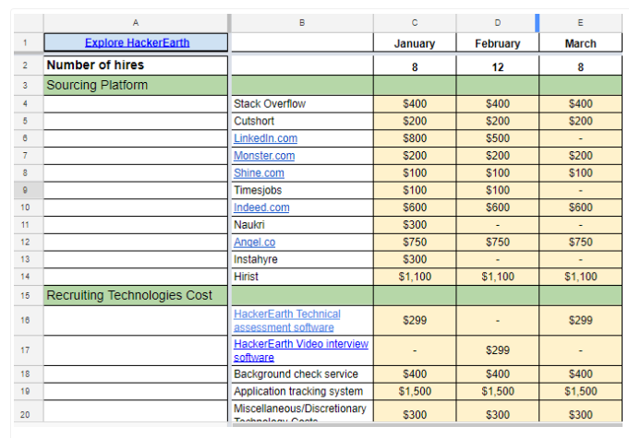

- Selection Methods
Selection is the process of hiring the right person for the right job at the right time. It comes next after recruitment. The recruitment process generates a pool of potential candidates. The HR will select from these pools using a variety of methods. The first goal is to short list the applicants and then select among the shortlisted the top ten or top four and then chose which among the survivor is worthy. Several methods may be used for selecting employees among the most popular are resume, personality test, drug testing and work sample test.
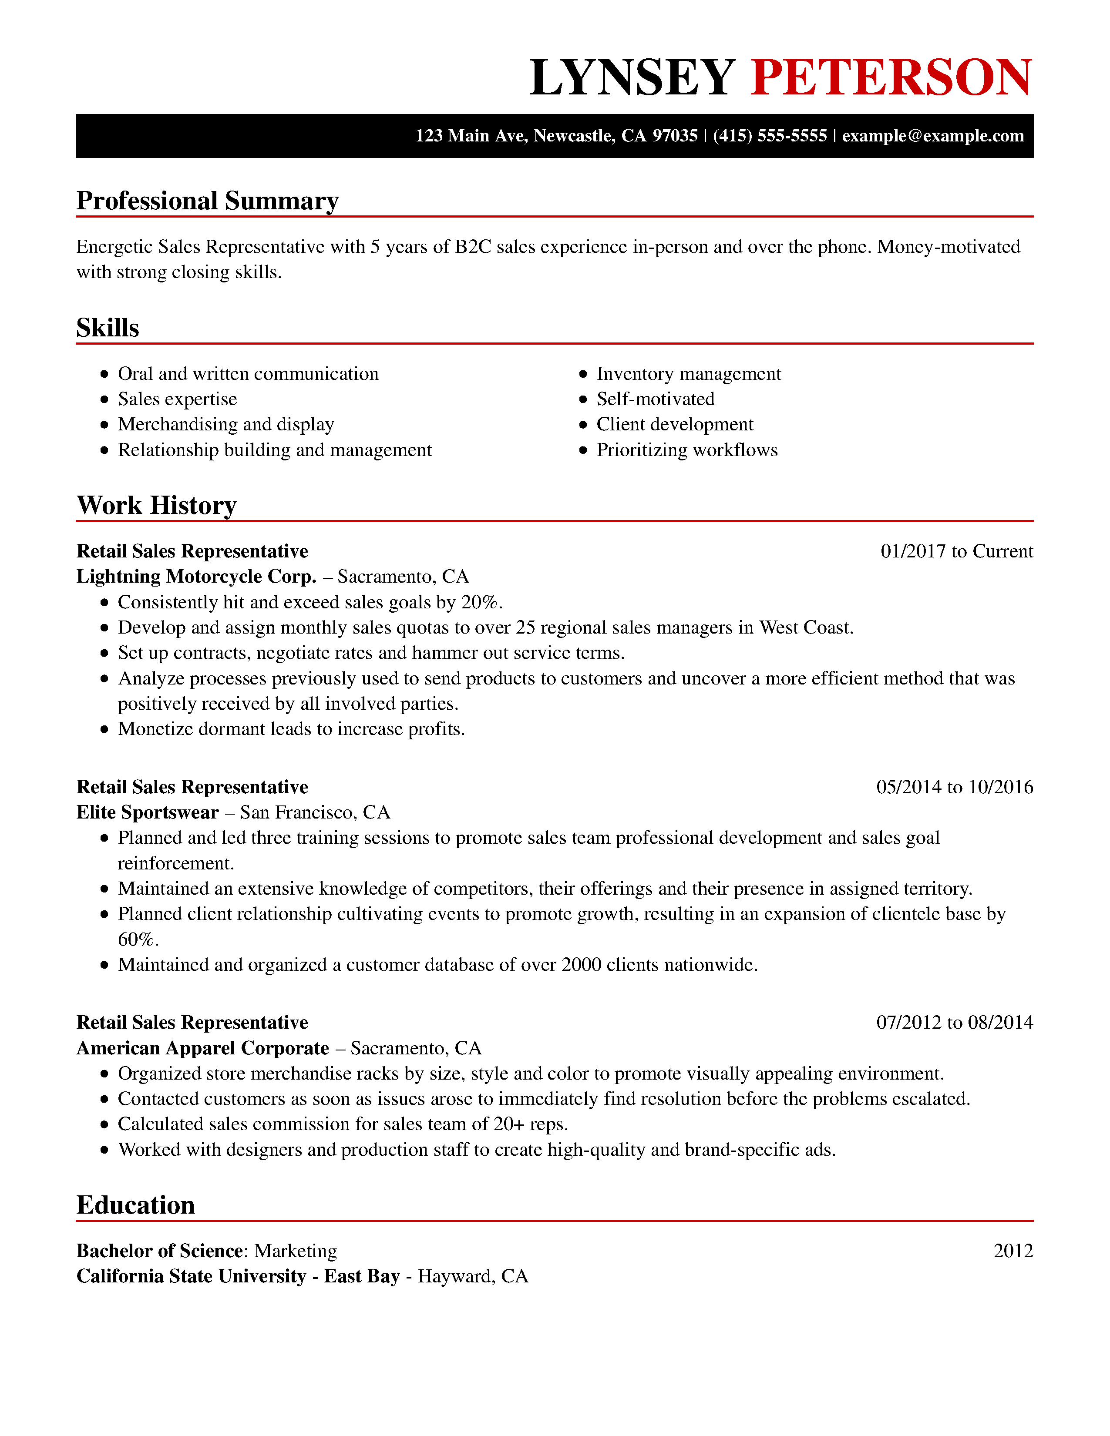
- Resume- is a short document that contain a summary of the applicant experience and qualifications (Arthur, 2012). It contains the following information contact information, education, training and seminars, work experience, and relevant skills relevant to the vacant position. The resume is usually hand in together with a letter of intent or application letter. The letter and the resume will provide enough information to make inform decision to shortlist or not an applicant.

- Personality test-once an applicant is shortlisted, he may undergo screening methods and one of these is personality test. Personality test allow the employer to determine if the applicant will fit in the job. This tool provides insights on the interaction style, personality traits and behavioral tendencies of the individuals. Some personality test allows employers to measure leadership potentials.
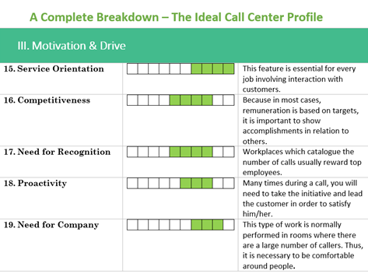
- Drug testing- in today’s work environment, safety should be maintained at all levels and all the time. Employers are now requiring applicants to undergo drug testing. This is to ensure that everyone that enters the organization will not cause problem in the future. It also helps eradicate drug use and misuse in the society as people will have to stop taking drugs in order to get a job.
- Work sample is another tool for selecting employees. If the job position is computer programing, the applicant must provide the employer a sample of a program, the applicant has made. Combined with personality test, the resume and interview, work sample and will determine if the applicant is hired or not.
VI. Interviewing Techniques
The last phase of selection is interview. There are usually two sets of interviews, the initial interview and the final interview. Initial interview is conducted after the applicant is short listed, while the final interview is conducted after surviving the several selection hurdles. There are three types of interviewing techniques presented in this paper and these are web interview, face to face interview and phone interview.
Phone interview are interviews conducted through phone. It is not as effective as the other types of interview and the purpose is to get as much information as possible.
Web interview is interview using computers and video phones and the internet. It superior to phone interview as it allows face to face interaction. The interviewer can see the facial reaction of the interviewee which could help in the assessment.
Face to face interview is the best type of interview because it allows the interviewer to the candidate physical, including behavioral cues and mannerism. This information combined with the selection hurdles above will allow HR to make inform decision in hiring the candidate.
- Conclusion
Recruitment and selection are a regular process in the company as employees may come and go or the company may experience growth. The process includes numerous phases and techniques which are discussed in this paper. The process is also costly and needs budget. Recruitment and selection needs planning, from deciding the budget to choosing the right selection methods. A carefully plan recruitment and selection will yield organizational success.

References
Arthur, D. (2012). Recruiting, interviewing, selecting and orienting new employees. Retrieved May 3, 2019 from https://ebookcentral-proquest-com.library3.webster.edu
Ash, R. (2013). The recruitment and selection of principals who increase student learning.Education. 134 (1) 94-100.
Bondarouk, T. 1., & Olivas-Lujan, M. R. I. (Eds.). (2013). Social media in human resources management. Retrieved May 3, 2019 from https://ebookcentral-proquest-com.library3.webster.edu
Deery, S. (2014). A moderated mediation analysis of job demands, presenteeism, and absenteeism Journal of Occupational and Organizational Psychology, 87, 352–369
Leonard, K. (2019). Methods of HR Selection Techniques. Retrieved May 3, 2019 from http://smallbusiness.chron.com/methods-hr-selection-techniques-57856.html.
Mitchell, S. (2007). Is Your Employment Brand: Is it Working for or Against You? Nursing Economic. 26 (20) 128-121. 3p.
Pritchard, C. W. (2007). 101 Strategies for Recruiting Success: Where, When, and How to Find the Right People Every Time. New York: AMACOM. Retrieved May 3, 2019 from https://search-ebscohost-com.library3.webster.edu/login.aspx?direct=true&db=nlebk&AN=164967&site=ehost-live
Shapiro, J. & Stanley, M., (2012). Cost Per Hire. Retrieved May 3, 2019 from https://www.shrm.org/ResourcesAndTools/business-solutions/Documents/shrm_ansi_cph_standard.pdf
Zahra, S. (2015). The Importance of a Strong Recruitment Process. Retrieved May 3, 2019 from Lucas Professional Group: http://www.lucaspsg.ca/the-importance-of-a-strong-recruitment-process/

