table of contents
chapter 1
Introduction
 | Introduction
 | Background of the research
 | Insights into Pharmaceutical Sector in Jordan
 | Motivations for the research
 | Research Problem
 | Research Questions and Objectives
 | Significance of Research
 | The overall structure of the study project
 | Summary
chapter 2
 | business customer satisfaction
 | SMM activities
 |  | Trendiness
 |  | E-WoM
 |  | Customisation
 |  | Entertainment
 |  | Interaction
 | H1: SMM activities affect business customer satisfaction in the pharmaceutical industry
 | the kano model for the pharmaceutical industry and the relationship with customer satisfaction
 | KANO Model (KM)
 |  | Attractive Quality (AQ)
 |  | One_Dimensional_Quality (ODQ)
 |  | Must_Be_Quality (MBQ)
 |  | Indifferent_Quality (IDQ)
 | H2(a): SMM activities affect KANO Model in the Jordanian Pharmaceutical industry.
 | H2(b): KANO affects customer satisfaction in the Jordanian Pharmaceutical industry.
 | Value Creation (VC)
 |  | The fourth section details the value creation in the pharmaceutical industry.
 | H3(a): Kano model is related to the value creation for b2b customers.
 | H3(b): KANO Model mediates between the SMM activities and value creations in the Jordanian Pharmaceutical industry.
 | H4: Value creation has a significant impact on B2B customer satisfaction in the Jordanian Pharmaceutical industry.
 | H5(a): Value creation mediates between the Kano Model and customer satisfaction in the Jordanian Pharmaceutical industry.
 | H5(b): Value creation serially mediates between the SMM and customer satisfaction in the Jordanian Pharmaceutical industry.
 | Transaction Efficiency (TE)
 |  | the quality of the connection that exists between transaction efficiency and business customer satisfaction
 | H6: Kano model affects the TE of the pharmaceutical firms in b2b customers.
 | H7: Transaction efficiency significantly impacts the B2B customer satisfaction in the Jordanian Pharmaceutical industry.
 | H8: KANO Model mediates between the SMM activities and Transaction Efficiency in the Jordanian Pharmaceutical industry.
 | H9(a): Transaction Efficiency mediates between the Kano Model and customer satisfaction in the Jordanian Pharmaceutical industry.
 | H9(a): Transaction Efficiency serially mediates between the SMM and customer satisfaction in the Jordanian Pharmaceutical industry.
chapter 3 | theoretical framework and research methodology
 |  | introduction
 |  | Study Framework
 |  | research philosophy
 |  | research design
 |  | research population
 |  | data collection
 |  | measurement instrument
 |  | the technique of data analysis
 |  | summary
chapter 4 | data analysis
 |  | reality validity
 |  | demographic information
 |  | multiple regression interpretations
 |  | CFA analysis
chapter 5 | discussion and conclusion
 |  | introduction
 |  | discussion
 |  | theoretical implications
 |  | practical implications
 |  | limitation
 |  | conclusion
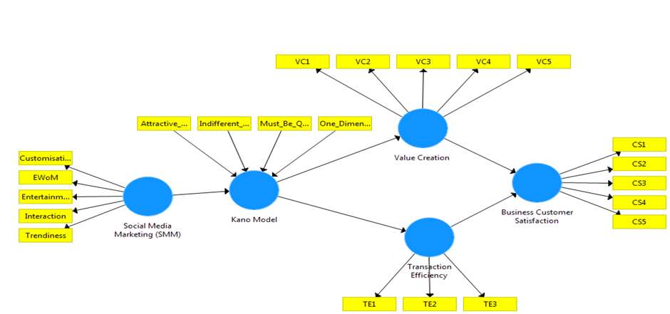

Section – I
Demographic Profile: Please kindly put a sign (x) in the appropriate box that represents your honorable person:

Gender | ☐Man | ☐Woman | ☐Others
Age Group | ☐18-24 years | ☐25-30 years | ☐31-40 years | ☐More than 40 years
Are you a Pharmacist | ☐Yes | ☐No
Status | ☐Single | ☐Married | ☐Divorced
Monthly Income (Dinar) | ☐Below 500 | ☐500-1000 | ☐1000-2000 | ☐Above 2000

Section – II
Please Tick a single option at the front of each question to show your level of agreement or disagreement.
1. Strongly Disagree 2. Disagree 3. More or less Disagree 4. Undecided 5. More or less agree 6. Agree 7. Strongly Agree
Sr. # | Question Statement | 1 | 2 | 3 | 4 | 5 | 6 | 7
Entertainment
 | Are the content of pharmaceutical firms interesting on social media platforms
 | Are the Pharma firms’ pages on social media platforms exciting?
 | Is it fun to collect information about Pharmaceutical firms on social media platforms?
 | Is it easy to spend time through Pharma firms’ social page
Customisation
 | Is it possible to search for customized information about Pharma firms on social media platforms?
 | Are Pharma firms’ pages on social media provide customized services?
 | Are Pharma firms provide lively feed information I am interested in on social media platforms?
 | Is it easy to use Pharma firms’ social pages?
Interaction
 | Is it easy to express your opinion through Pharma firms’ Social pages?
 | Is it easy to convey your conversation or opinion to SM's other users on the Pharma firms ‘pages?
 | Is it likely to establish a two-way interaction through Pharma firms’ pages SM platforms?
 | Is it probable to share information on Pharma firms’ SM pages with other customers?
Trendiness
 | Do you find the content of Pharma firms on social media platforms up to date?
 | Are Pharma firms’ using the trends on social media platforms?
 | Is the content of Pharma firms on social media platforms are the newest information?
Electronic Word of Mouth
 | Is it possible to share information with other users through Pharma firms’ pages on social media platforms?
 | Would you pass information about Pharma firms’ pages on social media to your friends?
 | Would you upload content about Pharma firms’ pages on social media platforms?
Source :Man Lai Cheung, Guilherme Pires, Philip J. Rosenberger(2019)
Indifferent_Quality
 | Customers are notified of product shipment one day prior through social media
 | Service personnel on social pages (i.e., order and delivery personnel) have professional training and a certain degree of understanding about drugs
 | Customized logistics processing and packaging services are available on social pages
 | There is no limit on order time on social pages
 | Customers can place online orders using the electronic platform/Online orders are accepted
 | Delivery services are available on weekends and holidays if reached through social pages
 | Customers receive order-processing status on social pages
 | Information on materials related to healthcare medicines and procurement advice are provided on social pages
 | Services such as medical waste recycling, waste disposal, and autoclaving are available on social pages
 | Escrow inventory services are provided on social pages
Must_be_Quality

 | Pharma firms have good word-of-mouth, reputation, and popularity
 | Processes including order content (items and quantities) and bill of lading documents are correctly executed through social pages
 | Processes for batch numbers and validity period management are strictly implemented; i.e., drugs with a validity period of less than 6 months are not displayed on social pages
 | The rate and extent of damage received are disclosed/low on social pages
 | Logistics equipment and distribution vehicles related temperature requirements of drugs can be shared easily on Social Pages
 | Goods are delivered on time to customers booked through social pages
 | The order (i.e., item and quantity) delivery rate is accurate through social media pages
 | Customer enquiries are answered within the promised period discussed on social pages
 | Return and exchange processes are prompt and appropriate through social media pages
 | Service personnel (i.e., order and delivery personnel) quickly address delivery errors on social pages
 | Customers are notified of delayed shipment on social pages
 | Service staff (i.e., order and delivery staff) are kind and courteous on social pages
 | Customers are notified of out-of-stock products on social pages
 | Customers are notified of product packaging changes in advance on social pages
 | Out-of-stock orders are promptly processed on social pages
 | Customer complaints are immediately addressed and resolved on social pages
 | Shipment of damaged goods or incorrect invoices and bills of voucher are promptly corrected on social pages
 | Social media customer service staff provides professional and satisfactory answers on social pages
 | The social pages of Pharma firms are accurate and error free
 | Pharma Firms have advanced equipment (e.g., warehouses, pickup systems, shelves)
 | Deliveries are made as per time specified by customers on social pages
 | There are channels for customer complaints on social pages
 | Inventory location or shelf service is designated as per customer needs on social pages
 | Batch number and validity period requirements specified by the customer are met on social pages
One_Dimensional_Quality
 | Urgent orders are accepted through social pages and processed with timely delivery
 | Deliveries are completed every other day after receiving the order on social media
 | Information technology (RFID and barcode) offers information on drug history and temperature control on social pages
 | There is a limit on the minimum order amount on social pages
Source : Mu-Chen Chen a,* , Chia-Lin Hsu b , Li-Hung Lee (2020)
Value Creation
There is a new customer value created in terms of transaction
efficiency when using the Social Media Marketing Activities (SMMA)
There is a time-efficiency benefits when choosing to use the
SMMA
There is an energy-efficiency benefits when choosing to use the
SMMA
SMMA provides a various payment options that benefits
the Pharmacists
SMMA provides a various delivery options that benefits
the Pharmacists when purchasing products
Source : Andika Putra Wijaya1 , Innocentius Bernarto , Agus Purwanto(2020)
Transaction Efficiency
 | The transaction process benefits the pharmacists when running a pharmacy business
Pharmacists are being benefited by the SMMA because it gives
a wide range of delivery options
The adaptation process is much easier because the SMMA
features are easy to be learned.
Source : Andika Putra Wijaya1 , Innocentius Bernarto , Agus Purwanto(2020)
Customer Satisfaction
 | I am more benefited because of the quickness of transaction process
 | I am more benefited because of the wide range of products that being offered
 | I am more benefited because of better price point compared to the conventional firms
 | I am more benefited because of the quickness when processing personal data
Source : Andika Putra Wijaya1 , Innocentius Bernarto , Agus Purwanto(2020)

